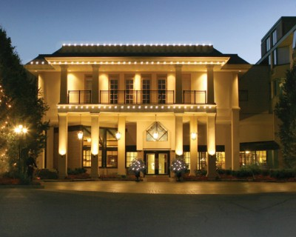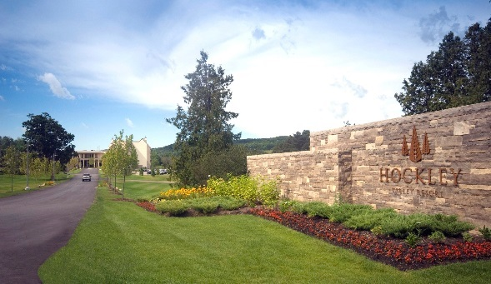

CIAA ONTARIO REGION CONVENTION

June 1st – 3rd, 2017
Hockley Valley Resort
Mono, Ontario

AGENDA

Thursday, June 1, 2017 1:00 pm – 2:00 pm Registration
2:00 pm - 5:00 pm Annual General Meeting
6:00 pm - 8:00 pm Dinner
8:00 pm - 12:00 am Hospitality Suite

Friday, June 2, 2017 7:00 am - 8:30 am Breakfast
9:00 am Golf or Spa
6:00 pm - 9:00 pm President’s Dinner
9:00 pm - 12:00 am Hospitality Suite

Saturday, June 3, 2017 7:00 am - 8:30 am Farewell Breakfast

REGISTRATION Single $350.00/Couple $400.00 (Lodging extra)
Golf or Spa Treatment (Up to $100.00 Included)

Remit to: CIAA Ontario Region
c/o CIAA National Office

5401 Eglinton Ave. W., Suite 100
Etobicoke, ON M9C 5K6
E-mail: info@ciaa-adjusters.ca

Last Name:____________________________________ First Name:______________________
Company:_____________________________________________________________________
Address:______________________________________________________________________
City:____________________ Province:_______________ Postal Code:___________________
Phone:__________________ Fax:____________________ E-mail:______________________
Guest/Companion:______________________________________________________________

Golf or Spa Treatment (please circle): Golf or Spa Treatment (Please circle):
Name:______________________________ Name:____________________________________
**For Golf please contact Kumar directly at: ksivakumaran@cl-na.com
**For Spa Treatment please contact Hockley directly

Room Rate – Single $189.00 plus tax /Double $101.50 per person plus tax
Hockley Valley Resort Reservation: Toll Free: 1-866-462-HOCKLEY (462-5539)
*On booking advise part of CIAA to receive conference rate*

