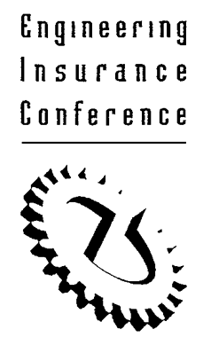

The Canadian Boiler and Machinery Underwriters Association
48th Annual Engineering Insurance Conference
Virtual Conference via Zoom
October 13, 2021

Greetings AEIC Attendees:

Our annual conference is fast approaching - Wednesday, October 13, 2021. We encourage you to register soon and join us (virtually) for another exciting conference! A reminder that registration is free, and you do not have to purchase any tickets this year.

Here is our agenda for the day:

Morning Session

8:45 – 9:00am Welcome and Introductory Remarks
Speaker: Mr. Paul Lucarelli, SVP – Specialty Solutions Canada, Intact

9:00 – 10:00am Presentation #1: “Cloud Blindness”
Speaker: Paul Morris, HSB

10:15 – 11:15am Presentation #2: “Virtual Reality, Machine Learning and AI in Insurance”
Speaker: Rob Mikulec, COO, Utilant

Register for the Morning Session using this link:
Please register for the Morning Session using this link

Afternoon Session

1:00 – 2:00pm Presentation #3: “Avoiding Failures of Rotating Equipment Through Modernization”
Speaker: Ken Huber, Haag Global

2:15 – 3:15pm Presentation #4: “Additive Manufacturing – What is a Proven 3D Printed Component and Potential Uses to Mitigate Claims”
Speaker: Ed Paprocki & Wei Zhang, HSB

3:15 – 3:30pm Closing Remarks

Register for the Afternoon Session using this link:
Register for the Afternoon Session using this link.

If you have any issues with registration or if you have any other questions, kindly email EngineeringInsuranceConference@gmail.com.

Yours truly,
Amanda Sorsak
Chair

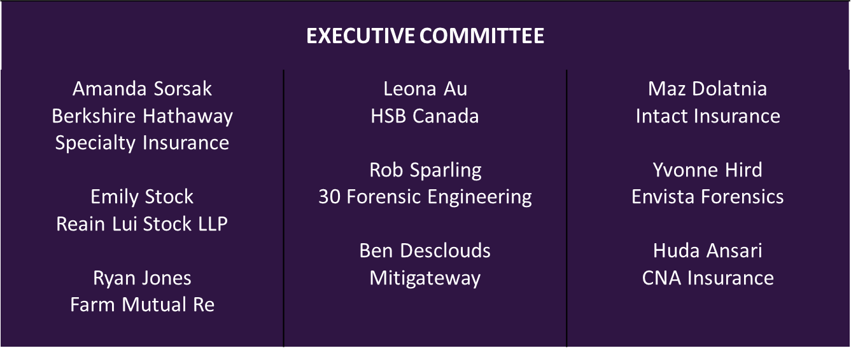

We would like to acknowledge our long-term sponsors:

